**Python Assignment 14**

1. What does RGBA stand for?

RGBA stands for "Red Green Blue Alpha." It is a color model used to represent colors in a digital image or on a screen. RGBA is an extension of the RGB color model, where an additional channel, known as the alpha channel, is used to represent the transparency or opacity of a pixel.

In the RGBA color model:

Red (R) represents the intensity of the red color component.

Green (G) represents the intensity of the green color component.

Blue (B) represents the intensity of the blue color component.

Alpha (A) represents the transparency or opacity of the pixel. A higher alpha value indicates greater opacity, while a lower alpha value indicates greater transparency.

2. From the Pillow module, how do you get the RGBA value of any images?

To get the RGBA (Red Green Blue Alpha) value of any pixel in an image using the Pillow (PIL) module in Python, you can use the getpixel() method. Here's how you can do it:

from PIL import Image

# Open an image

image = Image.open('example.png')

# Get the RGBA value of a specific pixel (x, y)

x = 100

y = 200

rgba_value = image.getpixel((x, y))

print(f'RGBA value at ({x}, {y}): {rgba_value}')

In this example, the getpixel() method is used to retrieve the RGBA value of the pixel at the specified coordinates (x, y) in the image. The result is a tuple containing the red, green, blue, and alpha components of the pixel.

3. What is a box tuple, and how does it work?

A box tuple, often referred to as a bounding box tuple or simply a "box," is a data structure used to define a rectangular region or area within an image. It is represented as a tuple containing four values: (left, upper, right, lower), where:

left: The x-coordinate of the left edge of the box.

upper: The y-coordinate of the upper edge of the box.

right: The x-coordinate of the right edge of the box.

lower: The y-coordinate of the lower edge of the box.

The box tuple is commonly used in image processing libraries, such as Pillow (PIL), to specify regions of interest, cropping areas, or bounding boxes around objects in an image.

Here's how a box tuple works in the context of the Pillow (PIL) library:

from PIL import Image

# Open an image

image = Image.open('example.png')

# Define a box tuple (left, upper, right, lower)

box = (100, 150, 300, 350)

# Crop the image using the box tuple

cropped_image = image.crop(box)

# Display or save the cropped image

cropped_image.show()

4. Use your image and load in notebook then, How can you find out the width and height of an

Image object?

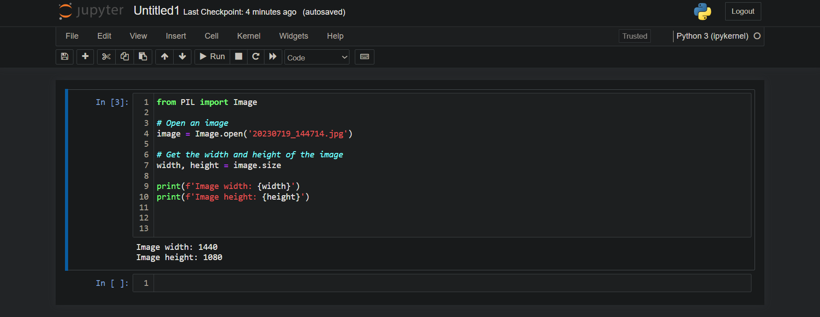

5. What method would you call to get Image object for a 100×100 image, excluding the lower-left

quarter of it?

To exclude the lower-left quarter of a 100x100 image and obtain an Image object for the remaining portion, you can use the crop() method from the Pillow (PIL) library. Here's how you can achieve this:

from PIL import Image

# Open an image

image = Image.open('example.png')

# Define the box tuple for the upper-right three-quarters (left, upper, right, lower)

box = (0, 0, 100, 50)

# Crop the image to the upper-right three-quarters

cropped_image = image.crop(box)

# Display or save the cropped image

cropped_image.show()

In this example, the crop() method is used to create a new image that includes only the upper-right three-quarters of the original 100x100 image. The box tuple (0, 0, 100, 50) specifies the region to be included in the cropped image.

6. After making changes to an Image object, how could you save it as an image file?

After making changes to an Image object using the Pillow (PIL) library in Python, you can save it as an image file using the save() method. Here's how you can do that:

from PIL import Image

# Open an image

image = Image.open('example.png')

# Make changes to the image (e.g., cropping, resizing, filtering, etc.)

# Save the modified image to a file

image.save('modified_image.png')

# Optionally, specify the file format explicitly

# image.save('modified_image.jpg', 'JPEG')

7. What module contains Pillow’s shape-drawing code?

The shape-drawing code in the Pillow library is contained within the ImageDraw module. The ImageDraw module provides classes and functions for drawing various shapes, lines, and text on images created using the Pillow (PIL) library.

You can use the ImageDraw module to add shapes like lines, rectangles, ellipses, polygons, and text to your images. Here's a basic example of how you might use the ImageDraw module to draw a red rectangle on an image:

from PIL import Image, ImageDraw

# Open an image

image = Image.open('example.png')

# Create a drawing object

draw = ImageDraw.Draw(image)

# Draw a red rectangle

left = 50

upper = 50

right = 150

lower = 150

draw.rectangle([left, upper, right, lower], outline='red')

# Save or display the modified image

image.save('modified_image.png')

In this example, the ImageDraw module is used to create a drawing object (draw) associated with the image. Then, the rectangle() method of the drawing object is used to draw a red rectangle on the image.

8. Image objects do not have drawing methods. What kind of object does? How do you get this kind

of object?

Image objects themselves do not have drawing methods. Instead, drawing methods are available through the ImageDraw module, which provides a separate class called ImageDraw.Draw that has various methods for drawing shapes, lines, and text on Image objects.

To get an ImageDraw object and access its drawing methods, you need to create an instance of the ImageDraw.Draw class associated with the Image you want to draw on. Here's how you can do it:

from PIL import Image, ImageDraw

# Open an image

image = Image.open('example.png')

# Create an ImageDraw object

draw = ImageDraw.Draw(image)

# Use drawing methods on the ImageDraw object

draw.line((0, 0, 100, 100), fill='red')

draw.rectangle((50, 50, 150, 150), outline='blue')

# Save or display the modified image

image.save('modified_image.png')

In this example, the ImageDraw.Draw class is instantiated with the Image object image. Then, you can use the drawing methods provided by the draw object to add various shapes and lines to the image.